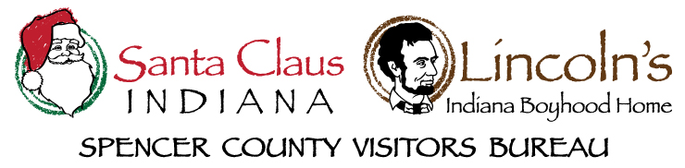

2023 TOURISM ENHANCEMENT GRANT
APPLICATION
Email:

Business or Organization Name:
____________________________________________________________

Contact Person:
____________________________________________________________

Business/Organization Address:
____________________________________________________________

Phone: ________________ Alternate Phone: ________________

Nonprofit (circle one): Tax ID# (if applicable):
Yes No _______________________________

General Business/Organization Description:

DESCRIPTION OF INITIATIVE
Fill in as much information as possible, specific to your request.

Details of Initiative:

*Attach additional details of the initiative if applicable.

Start date(s):
____________________________________________________________
Expected completion date(s):
____________________________________________________________

Location:
____________________________________________________________
Event or Business/Organization URL:
____________________________________________________________

What are the top three (3) goals for this initiative?
____________________________________________________________
____________________________________________________________
____________________________________________________________
____________________________________________________________
____________________________________________________________
____________________________________________________________

Total anticipated event attendance or annual traffic due to this initiative:
____________________________________________________________
____________________________________________________________
Non-local estimated attendance/traffic (possible overnights) due to this initiative:
____________________________________________________________
____________________________________________________________

Provide a description of the marketing/communications plan for promoting your initiative (include organic and paid efforts):
____________________________________________________________
____________________________________________________________
____________________________________________________________
____________________________________________________________
____________________________________________________________
*Attach a marketing/communications plan for promoting your initiative or additional information if applicable.

Describe how this initiative will increase overnight stays in Spencer County. Be specific about where people will come from and how they will find out.
____________________________________________________________
____________________________________________________________
____________________________________________________________
____________________________________________________________
____________________________________________________________
Provide a detailed strategy planned to measure initiative goals and tourism impact.
____________________________________________________________
____________________________________________________________
____________________________________________________________
____________________________________________________________
____________________________________________________________

FINANCIAL INFORMATION
Total annual budget of business/organization:
____________________________________________________________
Budget for this initiative (without tourism enhancement grant):
____________________________________________________________
Tourism Enhancement Grant request:
______________________________________________________

Provide a financial breakdown and list specific expenses for which the requested funds will be used:
____________________________________________________________
____________________________________________________________
____________________________________________________________
____________________________________________________________
____________________________________________________________
*Attach additional/supporting documentation regarding financial breakdown and expenses if applicable.

PARTNERS/COLLABORATION
List name, email address, and phone number of partners or contributors to this initiative. Attach additional information as needed.
____________________________________________________________
____________________________________________________________
____________________________________________________________
____________________________________________________________
____________________________________________________________
CERTIFICATION
On behalf of the organization identified on this application, I do hereby certify that the submitted application meets all the eligibility requirements for the Spencer County Visitors Bureau’s Tourism Enhancement Grant and the information included is accurate.
I understand that the grant funding of this initiative cannot be awarded prior to approval by the Spencer County Visitors Bureau and must be completed in date range provided.
To close the grant, a grant report must be submitted (along with vendors’ invoices and a copy of all promotional material, if applicable) to the Spencer County Visitors Bureau by the applying entity within sixty (60) days of completion, including any information regarding overnight visitation in Spencer County as a result of the initiative.

Signature:

On Behalf Of: ____________________________________________________________

Title: ____________________________________________________________

Date:
____________________________________________________________

